PROJECT NAME: Rehab Edge: Remote Physical Therapy with Edge AI
(GROUP – 04)
WIKI PAGE LINK: https://github.com/Sidduri2025/RehabEdge/wiki/Use-Cases-(iteration%E2%80%902)

USE CASES ITERTATioN - 2
- The system SHALL allow patients to create

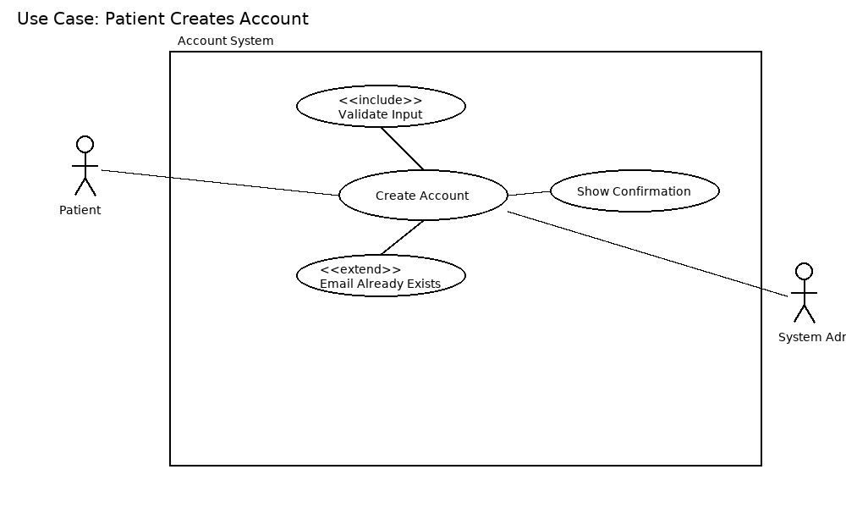
Use Case : Patient Creates Account
Actor : Patient
Scope: Account Management System
Brief: Patient registers a new account by providing required details.
Stakeholders: Patient, System Administrator (ensures system availability).
Preconditions: Patient does not already have an existing account.
Postconditions: A new patient account is successfully created.
Trigger: Patient selects "Create Account."
Basic Flow:
  - Patient selects "Create Account."
  - System prompts for personal details (name, email, password).
  - Patient enters details and submits.
  - System validates input.
  - System creates a new patient account.
  - Confirmation message is displayed.
Extensions:
  - 3a. Invalid or missing details → system shows error and requests correction.
  - 4a. Email already exists → system rejects and suggests login.

- The system SHALL allow patients to update their personal account details.

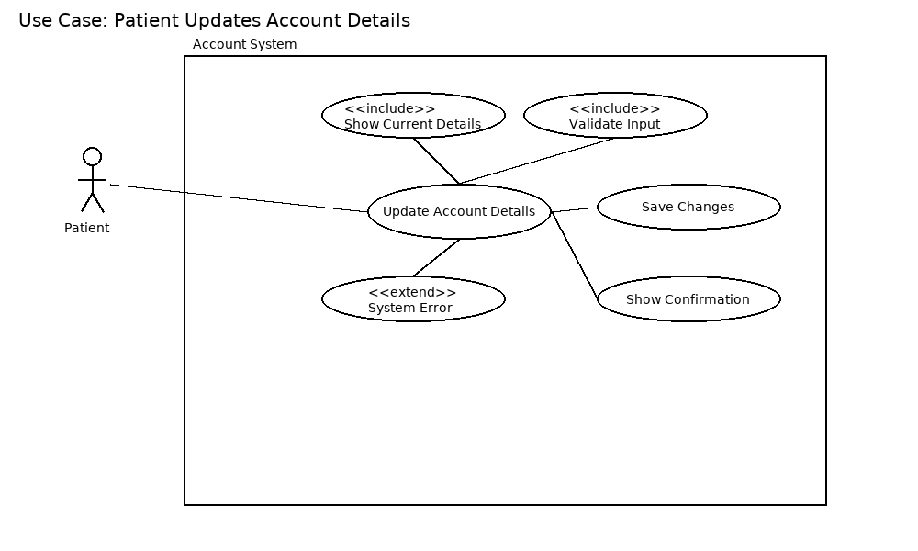
Use Case : Patient Updates Account Details
Actors: Patient
Scope: Account Management System
Brief: Patient modifies personal details like email, phone, or address.
Stakeholders: Patient, System Administrator.
Preconditions: Patient is logged in.
Postconditions: Updated account details are saved.
Trigger: Patient chooses "Update Account Details."
Basic Flow:
    - Patient logs in.
    - Patient selects "Update Account."
    - System displays current details.
    - Patient edits details.
    - System validates input.
    - System saves updated details.
    - Confirmation is shown.
Extensions:
- 5a. Invalid details entered → system prompts correction.
- 6a. System error → update not saved, error shown.

- The system SHALL allow patients to change their account password.

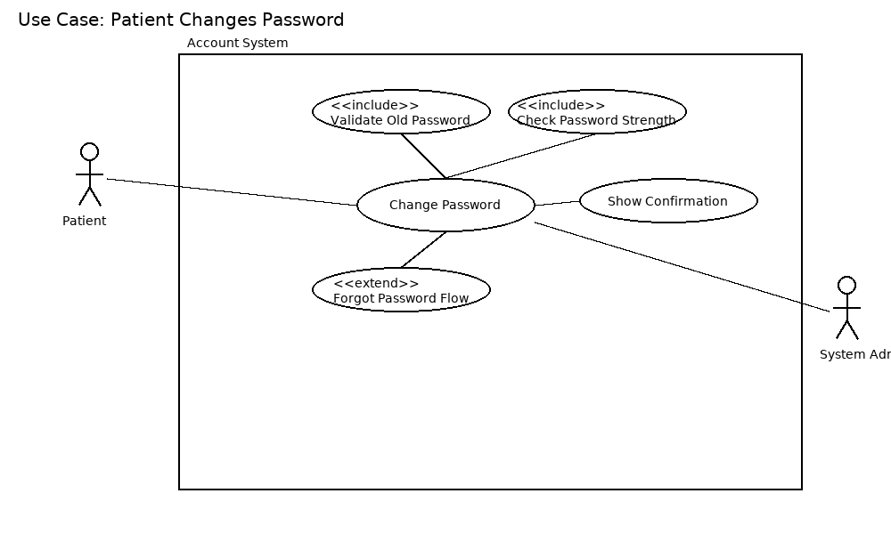
Use Case 3: Patient Changes Password
Actors: Patient
Scope: Account Management System
Brief: Patient updates their account password securely.
Stakeholders: Patient, System Administrator.
Preconditions: Patient is logged in and remembers the old password.
Postconditions: Password is updated successfully.
Trigger: Patient selects "Change Password."
Basic Flow:
  - Patient logs in.
  - Patient selects "Change Password."
  - System prompts for old and new password.
  - Patient enters required details.
  - System validates old password and new password rules.
  - System updates password.
  - Confirmation displayed.
Extensions:
  - 4a. Old password incorrect → system rejects request.
  - 5a. New password weak → system requests stronger password.

- The system SHALL allow patients to securely delete their account.

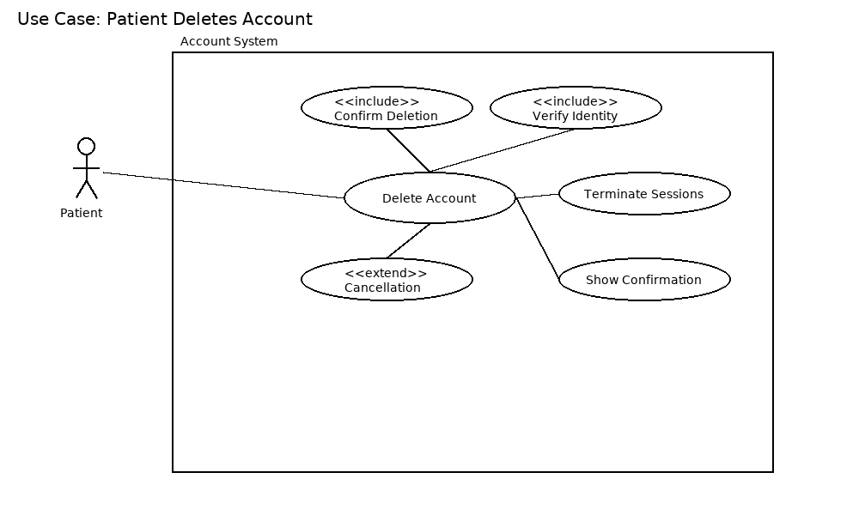
Use Case 4: Patient Deletes Account
Actors: Patient
Scope: Account Management System
Brief: Patient securely deletes their account.
Stakeholders: Patient, System Administrator.
Preconditions: Patient is logged in.
Postconditions: Account and related data are permanently removed.
Trigger: Patient selects "Delete Account."
Basic Flow:
  - Patient logs in.
  - Patient selects "Delete Account."
  - System asks for confirmation.
  - Patient confirms.
  - System deletes account data.
  - Confirmation shown and session ends.
Extensions:
  - 3a. Patient cancels → deletion aborted.
  - 5a. System error → account not deleted, error shown.

- The system SHALL allow doctors to create accounts.

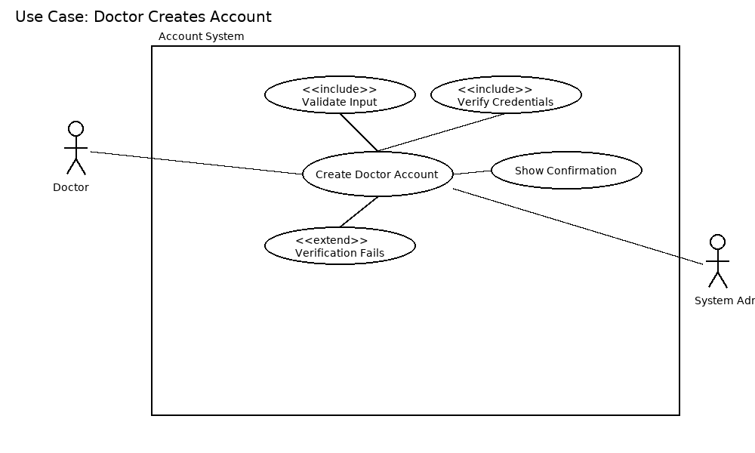
Use Case 5: Doctor Creates Account
Actors: Doctor
Scope: Account Management System
Brief: Doctor registers a new account by providing required details.
Stakeholders: Doctor, System Administrator.
Preconditions: Doctor does not already have an existing account.
Postconditions: A new doctor account is successfully created.
Trigger: Doctor selects "Create Account."
Basic Flow:
  - Doctor selects "Create Account."
  - System prompts for professional and personal details.
  - Doctor enters details and submits.
  - System validates input and verifies doctor credentials (if required).
  - System creates doctor account.
  - Confirmation displayed.
Extensions:
  - 3a. Invalid or missing details → system shows error.
  - 4a. Verification fails → account not created.

- The system SHALL authenticate user credentials using encryption.
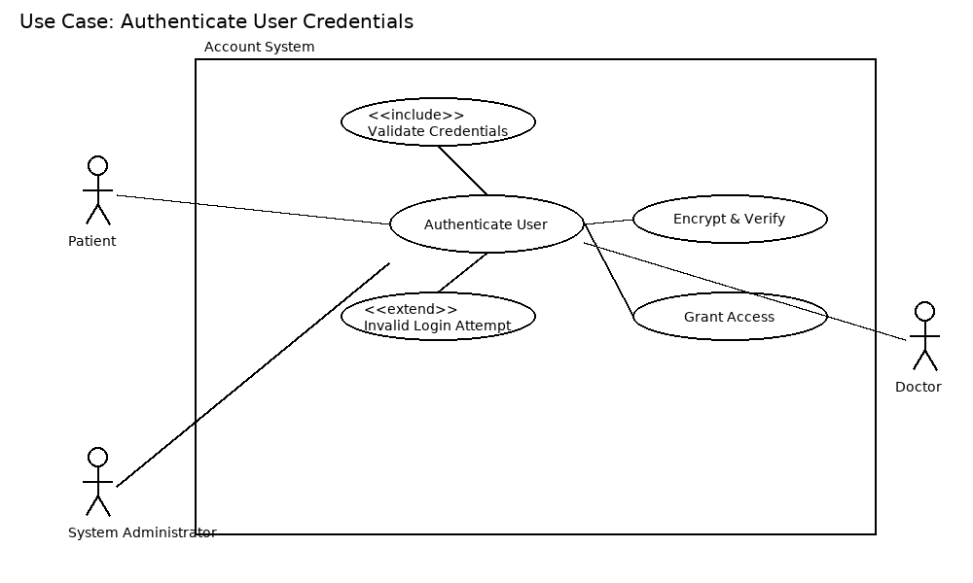
Use Case 6: Authenticate User Credentials
Actors: Patient, Doctor, Admin
Scope: Healthcare Management System
Brief: Validates user login using encrypted credentials.
Stakeholders: All users, Security Admin
Preconditions: User has an account.
Postconditions: User logged in or rejected.
Trigger: User enters login credentials.
Basic Flow:
- User enters username and password.
- System encrypts password and compares with stored hash.
- If matched → access granted.
Extensions:
- 3a. Invalid login → error message shown.
- 3b. Multiple failed attempts → account locked.

- The system SHALL send daily reminders to patients for scheduled therapy exercises.
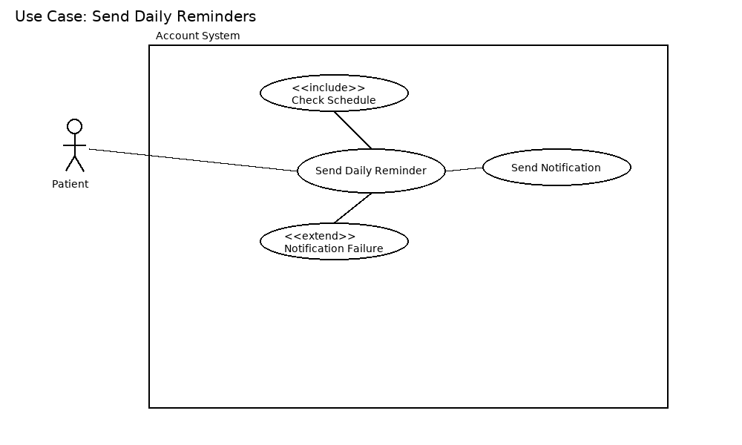
Use Case 7: Send Daily Reminders
Actors: Patient
Scope: Healthcare Management System
Brief: System sends daily exercise reminders to patients.
Stakeholders: Patients, Doctors
Preconditions: Patient has active therapy schedule.
Postconditions: Patient receives reminder notification.
Trigger: Daily scheduler triggers reminder.
Basic Flow:
- Scheduler checks patient’s therapy plan.
- System prepares reminder message.
- System sends via email/SMS/app notification.
Extensions:
- 3a. Network issue → reminder queued for retry.

- The system SHALL use the device camera to capture patient exercise sessions.
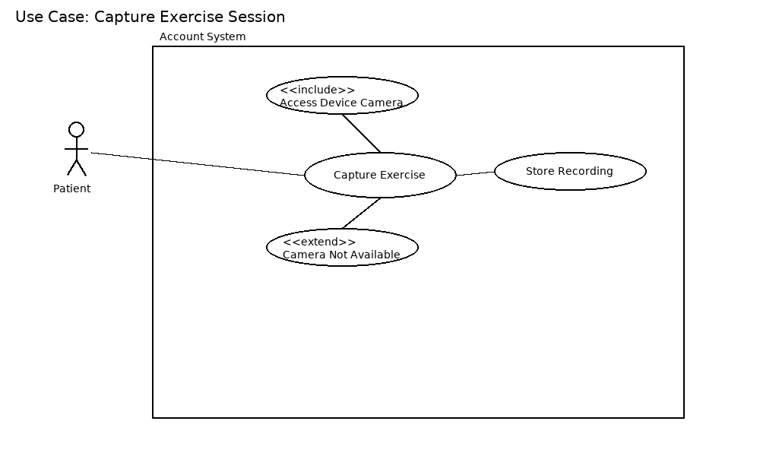
Use Case 8: Capture Exercise Session
Actors: Patient
Scope: Healthcare Management System
Brief: System uses device camera to capture exercise sessions.
Stakeholders: Patients, Doctors, Therapists
Preconditions: Patient has camera-enabled device.
Postconditions: Session video stored securely.
Trigger: Patient starts exercise session.
Basic Flow:
- Patient launches exercise capture.
- System requests camera access.
- Patient performs exercises.
- Session recorded and stored.
Extensions:
- 2a. Camera not available → error displayed.
- 4a. Storage full → recording stopped with warning.

- The system SHALL store exercise history for each patient.
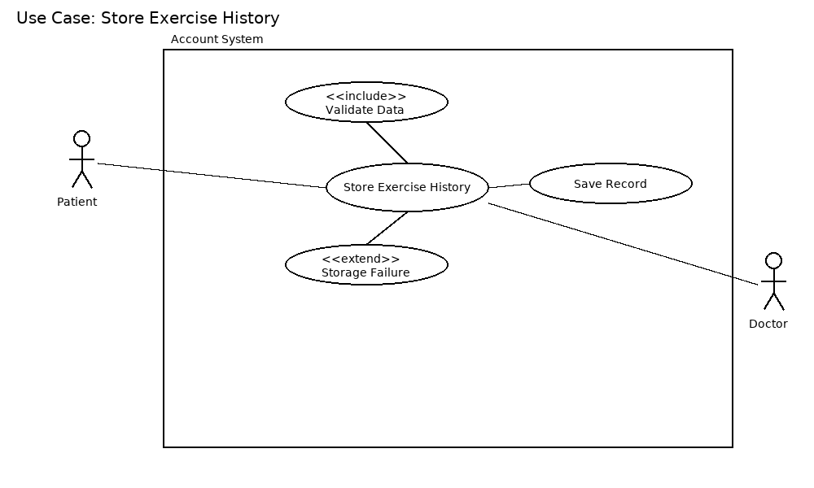
Use Case 9: Store Exercise History
Actors: Patient, Doctor
Scope: Healthcare Management System
Brief: Saves patients’ exercise activity history.
Stakeholders: Patients, Doctors
Preconditions: Patient performed exercises.
Postconditions: Exercise history stored in database.
Trigger: End of exercise session.
Basic Flow:
- System collects exercise data.
- Validates data.
- Stores into patient’s history log.
- Confirms storage success.
Extensions:
- 2a. Data invalid → system discards.
- 3a. Database unavailable → retry queued.

- The system SHALL provide doctors with a dashboard to view weekly progress and adherence.
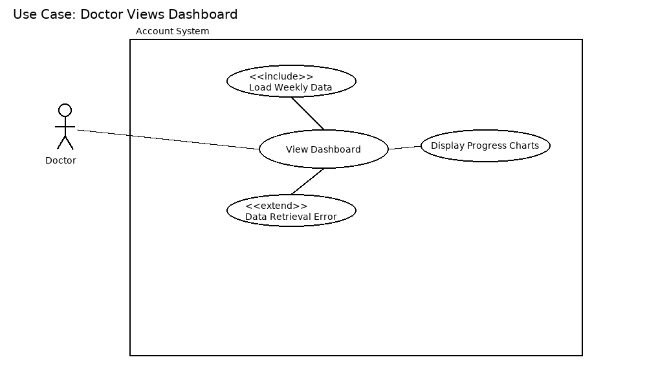

Use Case 10: Doctor Views Dashboard
Actors: Doctor
Scope: Healthcare Management System
Brief: Doctor reviews patient progress via dashboard.
Stakeholders: Doctors, Patients
Preconditions: Patients have recorded exercise history.
Postconditions: Weekly progress charts displayed.
Trigger: Doctor selects “Dashboard”.
Basic Flow:
- Doctor opens dashboard.
- System retrieves weekly exercise data.
- System generates charts/tables.
- Doctor reviews adherence and progress.
Extensions:
- 2a. Data retrieval error → error shown.
- 3a. No patient history → message displayed.

11.The system SHALL notify doctors when a patient misses multiple therapy sessions.

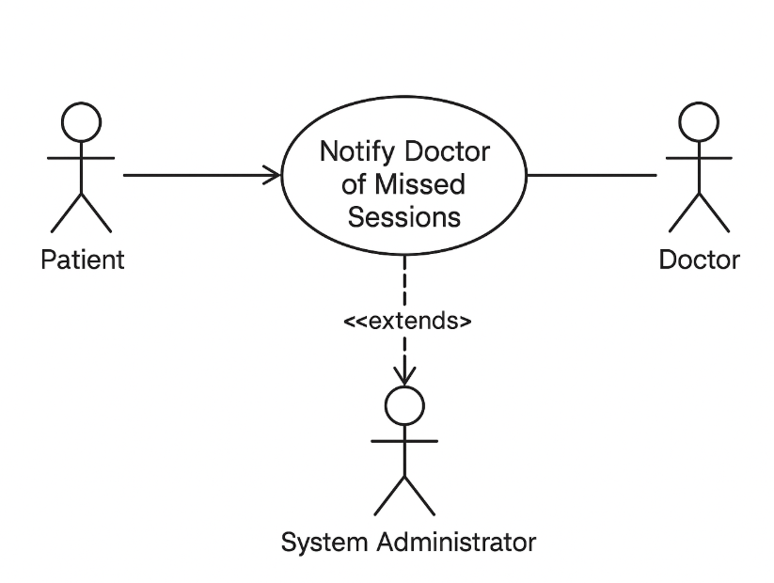

Use Case: Notify Doctor of Missed Sessions
Actor: System (primary), Doctor (secondary)
Scope: RehabEdge – Remote Physical Therapy
Brief: The system automatically tracks patient exercise sessions. If a patient misses multiple therapy sessions, the system notifies the doctor so appropriate action can be taken.
Stakeholders: Patient, Doctor, System Administrator
Preconditions:
- Patient is registered and has assigned sessions.
- System is actively tracking attendance.
Postconditions:
- Notification sent to Doctor.
- Patient record updated with missed session details.
Triggers:
- Patient misses multiple scheduled therapy sessions.
Basic Flow:
- System monitors patient session attendance.
- Patient misses more than the allowed number of sessions.
- System automatically generates a notification.
- Notification is sent to the Doctor.
- Doctor reviews patient status and may take necessary action.
Extensions (Alternate Flows):
- 2a. Grace Period: If the patient has a valid excuse (pre-approved leave), the system does not notify the doctor.
- 2b. System Error: If tracking fails due to technical error, the system alerts the administrator instead of the doctor.

12.The system SHALL NOT store passwords in plain text.

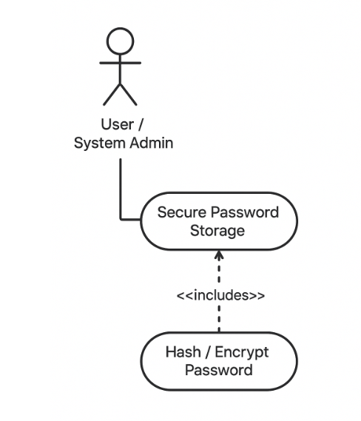
Use Case Name: Secure Password Storage
Actor(s): System, System Administrator
Scope: Application Security
Brief: The system must ensure that user passwords are stored securely using hashing and/or encryption, so that plain text passwords are never stored.
Stakeholders:
- System Administrator: Ensures security compliance.
- Users: Their passwords are protected from unauthorized access.
Preconditions:
- User account exists.
- Password is being created or updated.
Postconditions:
- Password stored securely in hashed/encrypted form.
- Plain text password is never retrievable.
Triggers:
- User creates a new account.
- User updates their password.
Basic Flow:
- User/System Administrator submits a new password.
- System hashes/encrypts the password using secure algorithms (e.g., bcrypt, SHA-256 with salt).
- System stores only the hashed/encrypted password in the database.
- User can authenticate later using the stored hashed password.
Exceptions / Alternative Flows:
- If hashing/encryption fails, an error is logged and the password is not stored.

13.The system SHALL generate visual progress reports for both patients and doctors.
Use Case Specification
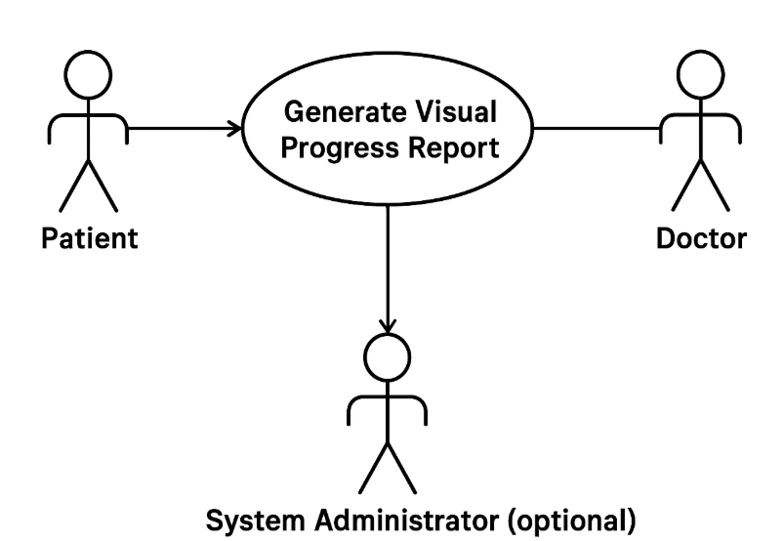
Use Case Name: Generate Visual Progress Report
Actors:
- Patient
- Doctor
- System Administrator (optional, for managing/report access)
Scope: RehabEdge – Remote Physical Therapy
Brief Description:
The system automatically generates visual progress reports (charts, graphs, summaries) to show a patient’s therapy performance over time. Both patients and doctors can view these reports to track improvement.
Preconditions:
- Patient has an account and therapy sessions recorded.
- Doctor has access to assigned patients.
- System is operational and has stored session data.
Postconditions:
- Visual report is generated and available for viewing.
- Reports may be downloadable or printable.

Triggers:
- Patient or doctor requests a report.
- Scheduled automatic report generation (optional).
Basic Flow:
- Actor (Patient or Doctor) selects the “Generate Progress Report” option.
- System retrieves relevant session and performance data.
- System generates visual report (charts, graphs, summaries).
- System displays report to the actor.
- Actor may download or print the report.

14. The system SHOULD generate a weekly summary of patient progress.
Use Case Description
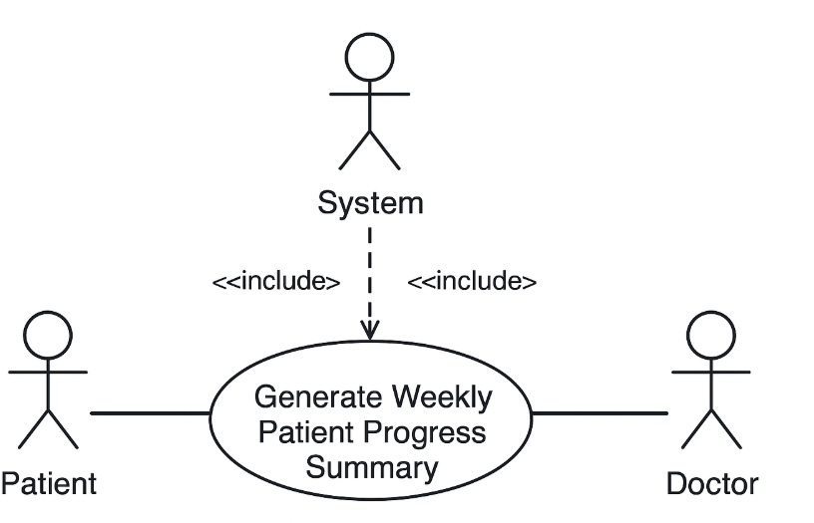
Use Case Name: Generate Weekly Patient Progress Summary
Actor(s):
- Patient – Receives the summary (optional if summary is only for doctors)
- Doctor – Views the summary for monitoring patient progress
- System Administrator – Ensures system generates summaries correctly
Scope: RehabEdge – Remote Physical Therapy System
Brief Description:
The system automatically collects data from patients’ exercise sessions and generates a summary report at the end of each week. This summary includes the number of sessions completed, improvements in performance, and areas needing attention. The report is made available to both the patient and the doctor.
Stakeholders:
- Patient (wants to track progress)
- Doctor (wants to monitor patient improvement)
- System Administrator (wants system functionality to work correctly)
Preconditions:
- Patient is registered and has completed sessions during the week
- Exercise data has been recorded accurately

Postconditions:
- Weekly summary report is generated and stored in the system
- Notifications may be sent to the patient and doctor that the report is available
Triggers:
- End of the week or doctor/patient request for the weekly summary
Basic Flow:
- System collects exercise data for the patient during the week.
- System analyzes performance metrics and progress.
- System generates a summary report.
- Report is stored in the system.
- Notification is sent to patient and/or doctor that the summary is available.
Alternative Flows:
- If data is missing for some sessions, the report indicates incomplete data.

15. The system SHOULD allow doctors to view historical exercise data for a patient
Use Case Description
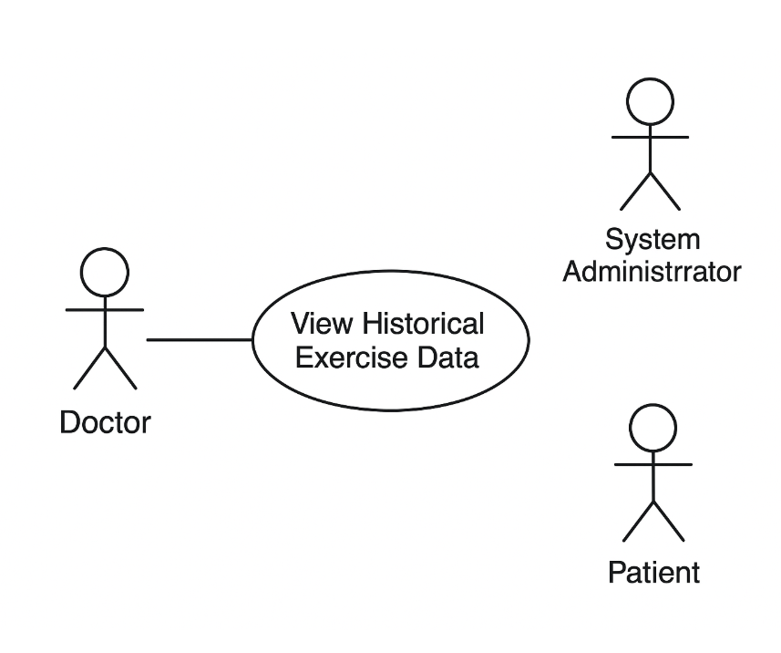

Use Case Name: View Historical Exercise Data
Actor(s):
- Doctor – main actor who views the data
- Patient – source of the exercise data
- System Administrator – ensures system functions properly
Scope: RehabEdge – Remote Physical Therapy
Brief Description:
The doctor can access a patient’s historical exercise data, including completed sessions, performance trends, and missed activities. This helps in assessing progress and adjusting treatment plans.
Stakeholders:
- Doctor (wants to monitor and analyze patient’s past performance)
- Patient (wants accurate history to be available)
- System Administrator (wants reliable functionality)

Preconditions:
- Doctor is logged into the system
- Patient profile exists with stored exercise data
Postconditions:
- Historical exercise data is retrieved and displayed to the doctor
Triggers:
- Doctor selects a patient’s profile and requests historical data
Basic Flow:
- Doctor logs into the system.
- Doctor searches for a specific patient.
- System retrieves stored exercise history.
- Doctor views the historical exercise data in a readable format (charts, tables, summaries).
Alternative Flow:
- If no historical data exists, the system displays a “No Data Available” message.

16. The system SHOULD allow Doctors to set personalized exercise plans per patient.
Use Case 16: Assign Personalized Exercise Plan

Actors:
Doctor (primary), Patient (secondary), System Administrator (support)

Scope:
RehabEdge – Remote Physical Therapy

Brief Description:
Doctor creates or updates an individualized exercise plan for a patient based on their medical condition and therapy goals.

Stakeholders:
Doctor – wants to design appropriate therapy plans
Patient – wants to receive personalized care
System Administrator – ensures system works properly

Preconditions:
Doctor is logged into the system
Patient profile exists

Postconditions:
Exercise plan is saved in the system and visible to patient
Notifications sent to patient

Triggers:
Doctor selects a patient to assign a new exercise plan

Basic Flow:
- Doctor logs into system
- Doctor selects a patient profile
- Doctor creates/updates an exercise plan (type, reps, schedule)
- System validates inputs and saves plan
- Notification sent to patient

Extensions / Alternative Flows:
- 3a: Patient profile incomplete → System requests missing details
- 4a: Schedule conflict detected → Suggests alternative times

Use Case Diagram:
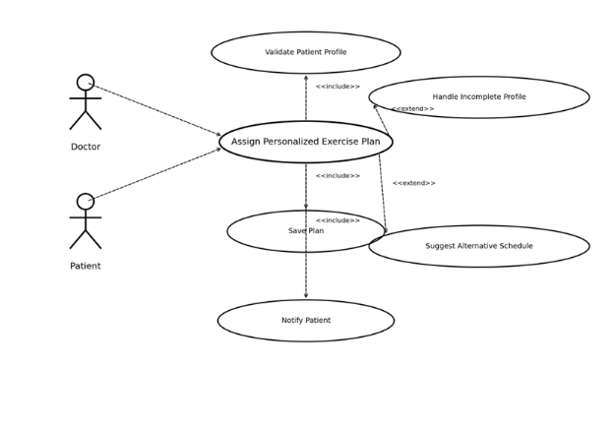

17.The system SHOULD notify patients about upcoming virtual appointments.

Use Case 17: Notify Patients of Virtual Appointments

Actors:
System (primary), Patient (secondary), Doctor (reference actor)

Scope:
RehabEdge – Remote Physical Therapy

Brief Description:
System automatically reminds patients of upcoming scheduled virtual appointments via notifications.

Stakeholders:
Patient – wants timely reminders
Doctor – expects patient attendance
System Administrator – ensures notification system works

Preconditions:
Appointment scheduled in system
Patient has valid contact details

Postconditions:
Notification sent to patient
Patient can confirm or reschedule

Triggers:
Appointment time approaches (e.g., 24 hours or 1 hour before)

Basic Flow:
- System checks upcoming appointments
- System generates reminder message
- Notification delivered to patient
- Patient acknowledges reminder

Extensions / Alternative Flows:
- 3a: Invalid contact details → Notification fails, system logs error
- 4a: Patient chooses to reschedule → Appointment updated

Use Case Diagram:
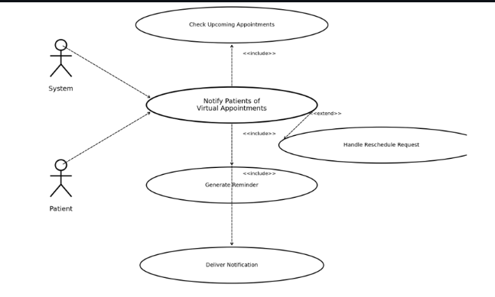

18. The system MAY allow patients to schedule virtual appointments with doctors.

Use Case 18: Patient Schedules Virtual Appointment

Actors:
Patient (primary), Doctor (secondary), System Administrator

Scope:
RehabEdge – Remote Physical Therapy

Brief Description:
Patients can request and schedule virtual appointments with available doctors.

Stakeholders:
Patient – wants to book appointments easily
Doctor – wants to manage schedule effectively
System Administrator – ensures calendar availability works

Preconditions:
Patient is logged in
Doctor availability is published

Postconditions:
Appointment booked and saved in system
Notifications sent to doctor and patient

Triggers:
Patient selects 'Schedule Appointment' option

Basic Flow:
- Patient logs into system
- Patient selects 'Schedule Appointment'
- System displays available doctor slots
- Patient selects preferred slot
- System confirms booking and sends notifications

Extensions / Alternative Flows:
- 3a: No slots available → System suggests alternatives
- 5a: Doctor rejects request → Patient notified with reschedule option

Use Case Diagram:
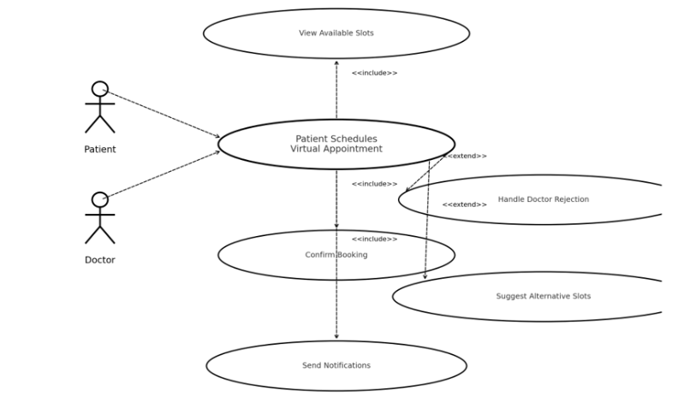

19 . The system MAY allow patients to manually log completed exercises.

Use Case 19: Patient Logs Completed Exercises

Actors:
Patient (primary), System Administrator (secondary)

Scope:
RehabEdge – Remote Physical Therapy

Brief Description:
Patient records their exercise completion manually in the system.

Stakeholders:
Patient – wants to track daily exercise
Doctor – uses logs for monitoring progress
System Administrator – ensures data is recorded properly

Preconditions:
Patient is logged in
Exercise plan assigned

Postconditions:
Exercise completion recorded in patient history

Triggers:
Patient selects 'Log Exercise' option

Basic Flow:
- Patient logs into system
- Patient selects assigned exercise
- Patient enters completion details (sets, reps, date/time)
- System validates and saves entry
- Updated progress shown in dashboard

Extensions / Alternative Flows:
- 3a: Patient enters invalid data → System prompts correction
- 4a: System error → Exercise not saved, error displayed

Use Case Diagram:

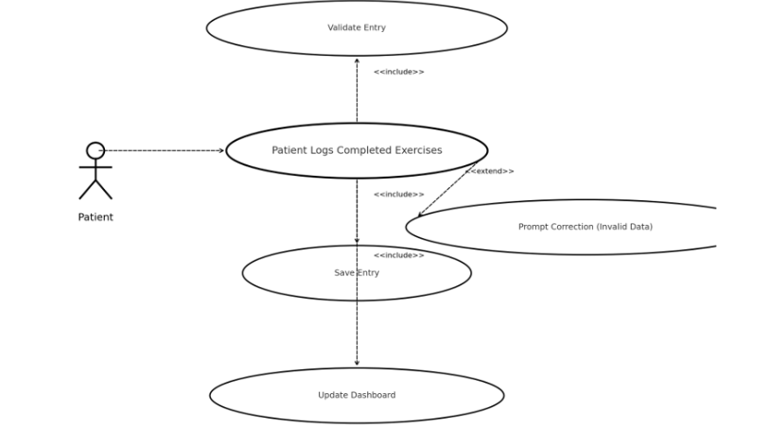

20 The system MAY allow patients to share progress reports with caregivers or family members.

Use Case 20: Share Progress Report

Actors:
Patient (primary), Caregiver/Family Member (secondary), System Administrator (support)

Scope:
RehabEdge – Remote Physical Therapy

Brief Description:
Patient can share progress reports (weekly/monthly summaries) with caregivers or family members.

Stakeholders:
Patient – wants family support
Caregiver/Family – wants to monitor patient progress
Doctor – ensures reports are consistent with treatment

Preconditions:
Patient has generated progress report
Patient is logged in

Postconditions:
Report shared with selected caregiver(s)

Triggers:
Patient selects 'Share Report' option

Basic Flow:
- Patient logs into system
- Patient selects 'Share Progress Report'
- Patient enters caregiver email/contact
- System shares report securely (link/email)
- Caregiver receives report notification

Extensions / Alternative Flows:
- 3a: Invalid contact info → System shows error
- 4a: Permission revoked → Report access disabled

Use Case Diagram:
